**PLEASE MOVE FIXED ISSUES TO FIXED BELOW**

Issues/Suggestions:

1. Looks like a list of names, maybe not distinguishable? Make User lists more user-friendly?

Fixed:

1. Franchisee, co-admin, commissary labels could be put in the first lines to make it easier to see? Maybe have a different color scheme for each type of user?
2. What happens when there is an error in the registration of a user?
   1. Error will be highlighted (red border)
3. Where is the password in the view user?
   1. Will add username and password
   2. Password is branchname+lastname+5th digit ng phone number
4. Not sure if akin lang, yung background colors minsan white minsan gray see pics below for examples
   1. White dapat background
5. Header may parang separator pa for each button and hindi pa buttons mga nasa header, smaller screen isnt accommodated

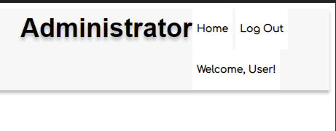

1. Landing page not in the center, buttons not clickable, scaling also has errors

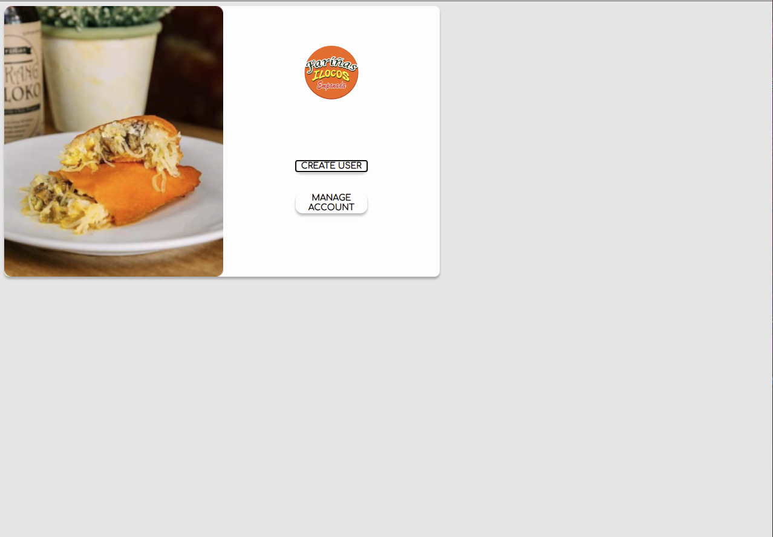

1. Manage_account is not in the center

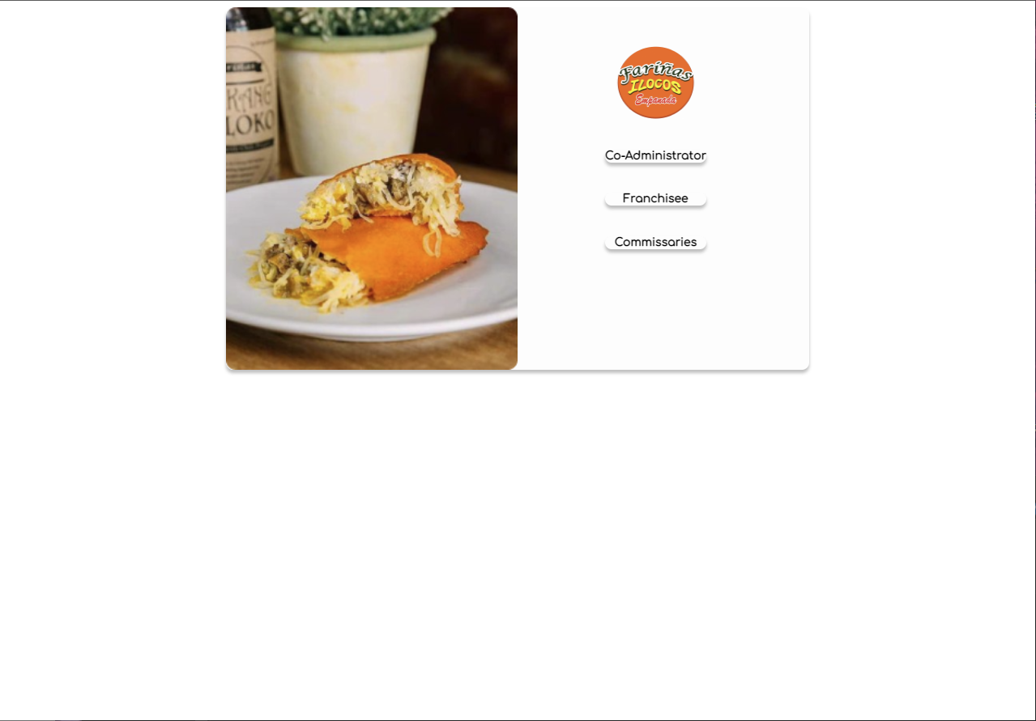

1. Registration is not in the center

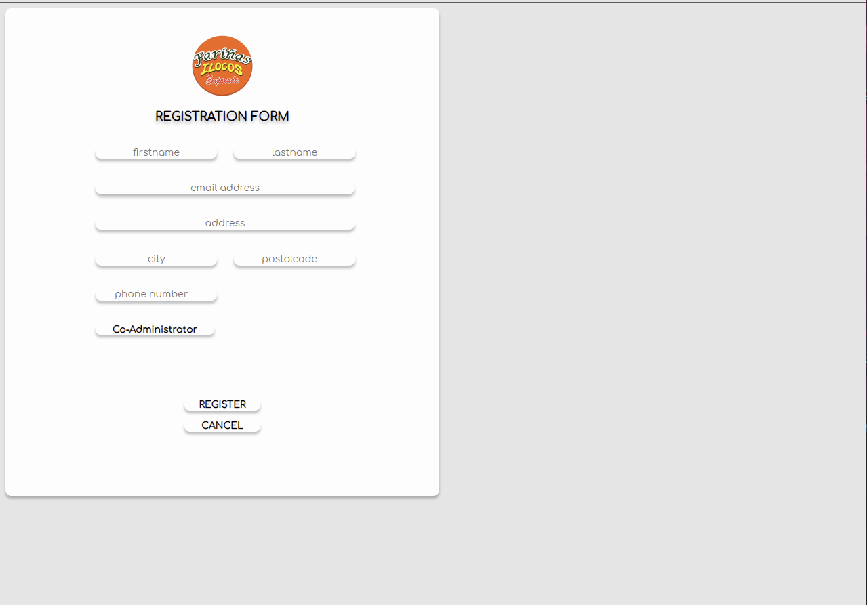

1. Edit_user does not match Figma (user type), text on buttons are turning into blue

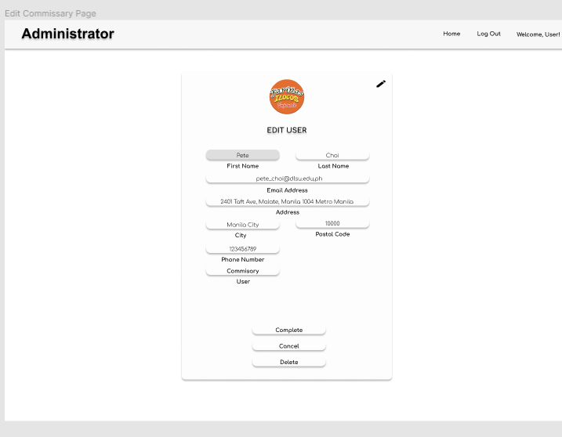

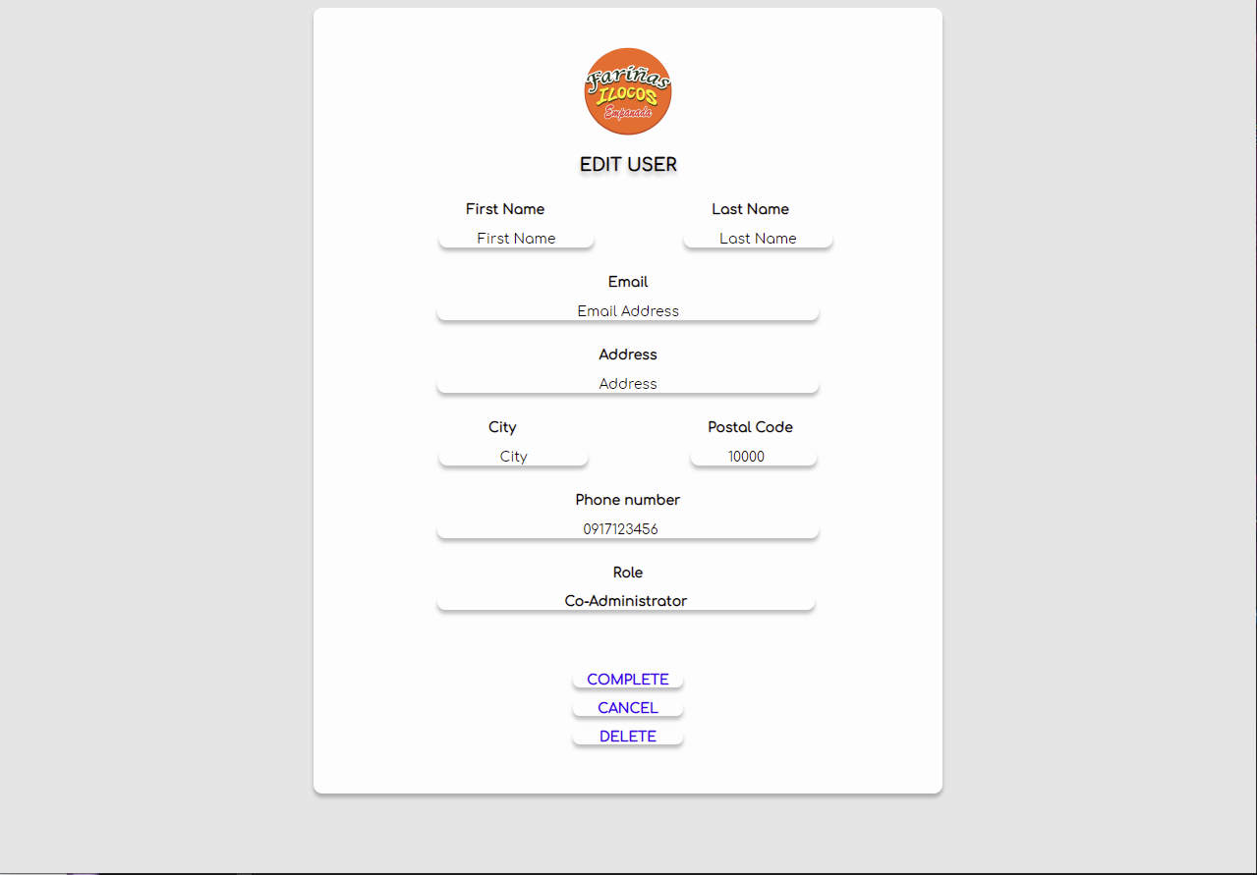

1. Signin not in the center, sign in is not a button

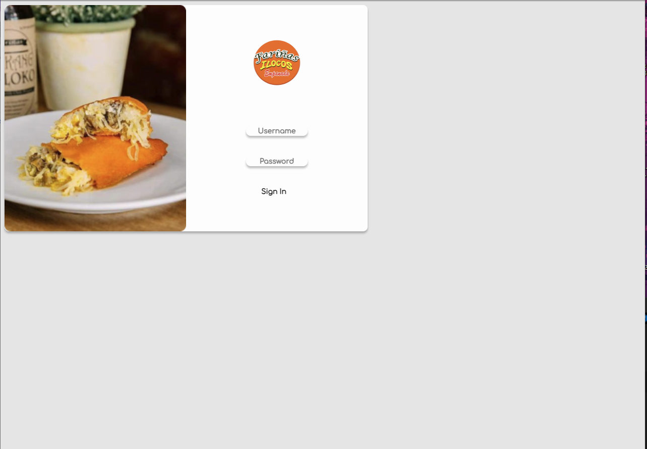

1. User_info not in the center, role has different style in figma

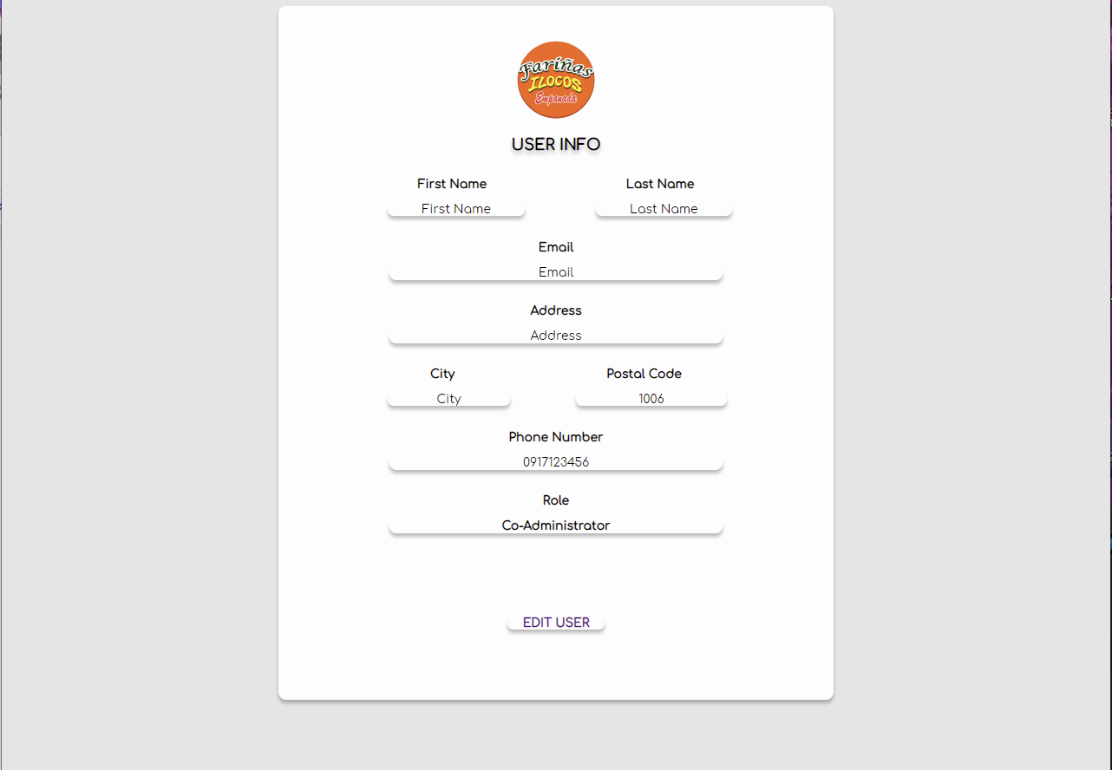

1. Generally, not centered in the y-axis
2. No back buttons yet
   1. Back button lipat sa upper left
3. Pop-ups not yet implemented
4. Postal Code?

FIXED